Mosquitoland
By: David Arnold

About the Author:

David Arnold is an accomplished writer and musician. Arnold lived in Jackson, Mississippi when he was young, and then moved from there to Ashland, Ohio. He now lives in Lexington, Kentucky with his wife and son. Arnold began writing his first novel Mosquitoland after learning that his wife was pregnant, realizing that one day he will be the father of a teenager. Having only written middle grade novels and adult short stories, Arnold never intended to write YA literature. “Writing for young adults is an incredible privilege, though it was never a conscious decision. I never set out to write YA, only to find the most unique, authentic voice I could” (Parnassus Musing, 2015).
http://davidarnoldbooks.com/
https://thesweetsixteens.wordpress.com
/2015/03/15/the-debut-club-an-interview
-with-david-arnold-author-of-mosquitoland/

Summary of the Novel:
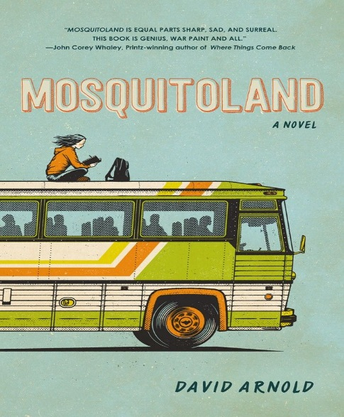
Sixteen year-old Mim (Mary Iris Malone) is not okay. She is struggling to accept her parents’ divorce, her new home in Jackson, Mississippi and her new stepmother. When Mim finds out that her mom is ill back in her hometown Ohio, Mim embarks on a 947-mile road trip across the country. Along the way, Mim meets some memorable strangers, is involved in a bus accident, and learns important life lessons. Mim finds herself physically and mentally, revealing truths about herself that she has never told anyone. Mim shares that she has solar retinopathy and is possibly suffering from psychosis. Despite facing many adversities, Mim comes to the realization that she just might be okay after all, making this quest a life-changing journey of self-discovery.
http://readeroffictions.com/wp-content/
uploads/2014/06/Mosquitoland-David-Arnold.jpg

Key Passages:
- “I close my good eye and see myself as I might look from above, as I might look to a mosquito hovering over a hot lake. I see Mim: her face pallid and feeble; her skin, pale, and glistening; he bones brittle and twiggy; an army of trees surrounding he. She floats next to a boy she met only hours ago,…‘Yeah, Walt. I might.’” (132)

In this moment Mim realizes that she is finally not alone and that it is okay to ask for help. Mim isolates herself from the world, leaving her alone to deal with issues that she finds difficult to overcome. In the beginning of the novel, Mim is called into the office by her principal in order to have a meeting between her and her father and his new wife Kathy, suggesting that Mim might be in trouble. It might just be that Mim is struggling to adjust to her new school. On top of that, she is reeling from her parents’ divorce and her separation from her mother. These are just two of the many reasons why Mim chooses to detach herself from the world. Mim chooses to hitchhike the rest of her trip after surviving a bus accident and being sexually assaulted by one of the passengers on the greyhound bus. After falling asleep on a bench, she meets Walt, a lively and lovable boy that unknowingly teaches Mim the value of friendship and that she is not alone.

- “And Suddenly, from months ago, my father’s voice: ‘Here, Mim.’ I take the bottle and roll my eyes. ‘Don’t look at me like that,’ says Dad. ‘I’m trying to help. Just get in the habit of taking one with breakfast everyday. Habit is king.’ I glance at the label on the bottle, wondering how it got this far…‘I’m not crazy.’” (160-161)

Mim remembers the day that her father made her begin taking medication. Her father believes she is “crazy” and only wants to help her “live a normal life”. After meeting another boy named Caleb, Mim learns that he might be the truth definition of crazy after over hearing him talk to himself and later, threatening to kill her and Walt after they attempt to run away from him. Mim compares herself to Caleb when he expresses that he is not “crazy”. Mim then finds out that Caleb possibly has schizophrenia. She then finds herself relating to him. This makes Mim reflect on whether she is really “crazy” or not, and if she really suffers from psychosis.

- “I unscrew the childproof lid, roll down my window, and hold out the bottle. I’m sure there are people that rely on Abilitol to get through the day. Hell, it’s probably saved lives. But thinking back to the last place I swallowed a full dose,…I’m seeing things much more clearly these days.” (342)

After a long journey of “tragic substance and despair” Mim empties out her prescription bottle of Abilitol. She realizes that much of her pain was a result of being alone and being misunderstood. Through her journey Mim was able to learn the importance of friendship and the importance of self-love. It is unclear whether Mim really has psychosis or not but for Mim, she feels better without the medication. She empathizes for people who might need to get through life but for her, the life lessons of her journey are enough for her to be just okay after all.

Exeter Qualities in the Novel
- Exciting plots that include secrecy, surprise, and tension brought about through narrative hooks and fast pace.

- Characters who reflect experiences of teen readers, something that is not found in much literary cannon, especially when it comes to strong female protagonists.

- Characters who go beyond typical experiences so that readers can use the fictional experiences to learn and develop in their own lives.

- Themes that inform truthfully about the wider world so as to allow readers to engage with difficult and challenging issues relating to immediate interests and global concerns.

- Themes that allow the possibility of emotional and intellectual growth through engagement with personal issues.

Text Complexity:
Mosquitoland is rated a 5.2 on the ATOS for reading level and 750 for lexile measure. The interest level is grades 9-12 and the text difficulty is rated a 4. There is profanity in the novel but other than that I liked the writing style of Arnold. There a lot of paragraphs and sentences that stood out to me because of Arnold’s use of witty phrases and well-constructed metaphors.

In the Classroom:
I would teach this novel to 10th and 11th graders. The novel addresses issues that still exist in today’s society that especially affect young adults. The novel is written in a first and third person perspective. Readers personally get to know Mim herself but also other characters. Mim writes several letters to her unborn sister Isabel, which makes the read feel as if Mim is almost directly speaking to them. I would present this book by first asking students to write about an experience of when they ever felt alone or misunderstood. What did they do? Did they seek help? How did they over come that experience? I would then ask students to write a letter to someone that may now be experiencing what they had once gone through. What advice would they give them? Arnold mentioned that he wrote lyrics based on the characters of Mosquitoland. Having students listen to some of these songs can help them make a better connection to the novel. As Arnold says, “A thing’s not a thing until you say it out loud”.

I believe that teens should read this book because it touches on real-life issues that are not talked about or often ignored. Some of these issues include, mental illness, sexuality, divorce, sexual abuse, and isolation. Young adults might find it difficult to share these issues because like, Mim they often feel that they are the only ones dealing with these issues. It great that books like these can shine light on issues that people are going through. Although Mosquitoland is a fictional novel, Mims and the characters’ personal issues are as real as can be. This connects with chapter 4 in Adolescents in the Search for Meaning, Books about Real-Life Experiences. This book is closely related to Speak. Both characters are young teenage girls that isolate themselves from the world because of deep personal issues. Through their own experience they are able to find themselves and learn to overcome their issues, but learn most importantly, they are going to be okay.

