4th Credit Enhancement Annotated Bibliography
Rational

The present world is full of trials and tribulations that are experienced in daily life. The past is full of those that can be studied through people from history. The future however can be experienced through the eyes of the imagination as anything is possible and nothing has yet been determined or set in stone. The post-apocalyptic genre is the pinnacle of exploring the future through the eyes of jarring changes to the present world. The “new world”, as a result of a demolished or drastically changed “current world” ,is a wonderful opportunity for young adults to allow their imagination to run wild through the scope of wide scale disrupt and survivalism. Though the post-apocalyptic genre can be seen as threatening or frightening, it provides an opportunity for young adults to explore situations that they would likely otherwise never encounter and that could greatly benefit them in their growth and development into adulthood. I began reading post-apocalyptic novels and viewing films when I was a young adult and I loved the element of the bare struggle to survive as it was something that I had not encountered in my life. The books that I have chosen for the annotated bibliography all exhibit elements of survival, adventure and love/friendship which are circumstances that teens will face at some point in the life in one way or another. Though they may not be saving the world they might find their own story of survival through the hardships that they encounter. Through the experience of others, teens’ experiences can find support in their own experiences. Knowing that one is never alone, and that others have survived through much harshing things than typical teens encounter is a beaming light of hope through the challenging teenage years.
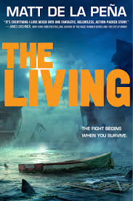
- Peña, Matt de la. The living. Ember, 2015.
  - Summary: Shy, a high school student, works on a cruise ship to help his family with the bills. His life is turned upside down when a catastrophic earthquake hits his home state of California and subsequent tsunami waves destroy the ship he is on leaving him lost at sea hoping to survive. In the aftermath of the natural disasters a mysterious illness is sweeping across the nation affecting Shy’s family and threatening to destroy the human population. Shy does everything he can to survive in order to help his family survive too.
  - Commentary: This book is valuable because it touches on many issues that are relevant to young adults’ lives, mainly disease, natural disasters, poverty, love and strength. The novel holds an essence of all the exeter qualities but there is one that are very prevalent throughout the novel. The Living exemplifies exeter quality two because it has a plot that involves elements of secrecy, surprise and tension through a fast pace and hooks. I find this to be most true in that the disasters and disease in the book continue to grow worse and there is a element of secrecy that travels throughout the book regarding what Addie’s dad’s company is doing and why they are interested in Shy.

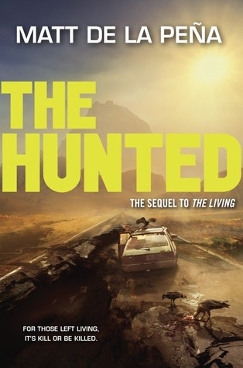
- Peña, Matt de la. The hunted. Ember, 2016.
  - Summary: Shy and his friends who survived a horrifying tsunami at sea that sunk their cruise ship and left them struggling to survive in the ocean and then on a small island, are traveling back to their home in California with something very important. They hold the only known vaccine for an illness that has decimated the west coast’s population after a catastrophic earthquake hit. The only problem is that the company that made the vaccine is hunting them down in an effort to hide their involvement in creating and spreading the disease knowingly for profit. Shy and his friends struggle to get the vaccine to the border in Arizona and encounter many trials and tribulations along the way.
  - Commentary: This book is valuable because it exemplifies multiple exeter qualities. The Hunted strongly embodies exeter quality two because it holds strong elements of secrecy, surprise and tension in the plot. The plot of this novel is full of twists and turns as well as secrets that are slowly unfolded throughout the novel but not fully revealed until the end. The novel also exemplifies exeter quality seven because it portrays themes that enable readers to grow emotionally through engagement with personal issues. The theme of love is woven throughout the novel as Shy continually struggles in his relationship with Carmen and his father. Another theme that is important in the story is acceptance. Shy works to find acceptance of his father, his relationship with Carmen, his role in saving the world and the fate of his family. Both love and acceptance are issues that teens may personally experience, and through reading this novel they will be better equipped to grow emotionally and handle such issues.

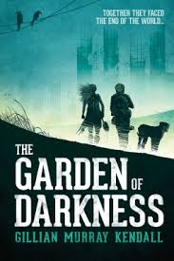
- Murray Kendall, Gillian. The Garden of Darkness. Ravenstone, 2014.
  - Summary: Four children find themselves together after a disease wipes out earth’s population. The group finds strength in their newfound friendships as they battle danger, hunger and survival all while searching for the last living adult who claims to have a cure for the disease. However, the true test is not in the disease that promises to kill them all, but in the ability they have to discover the meaning of friendship and forage a new world.
  - Commentary: This book is noteworthy because it holds within it many exeter qualities. The novel exemplifies exeter quality number one because it has a plot that is well structured in that it includes time shifts, from the present day, to before the pandemic overtook the population. It also includes shifts in perspective between Claire, Jeb and the Master. This leads right into exeter quality number two which is shown through the book’s element of secrecy as the reader knows some things that the other characters in the novel to not. The book also draws in the audience through narrative hooks particularly in waiting to find out if the cure the Master has will save the lives of the main characters. Lastly, the novel embodies exeter quality number four because it shows events and experiences that teens will most likely never have. This enables students to grow in their own lives through the experience of those in the novel. It poses questions to the reader such as: “What would I do in this situation?”, “I would I feel if I were her?” and “How does this relate to my own life?”.

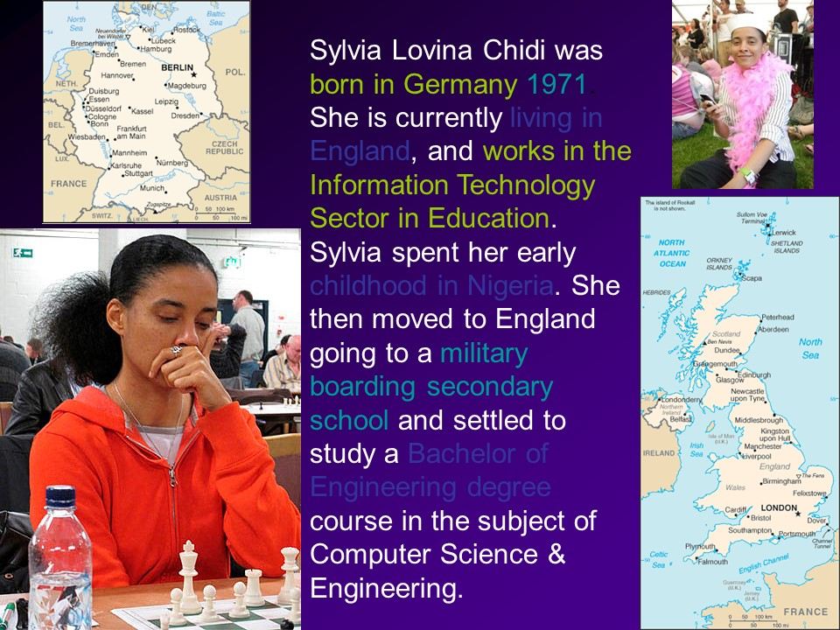
- Chidi, Sylvia. “Fear.”
I smell it here, I smell it near
In our hearts, body and soul we wear
Fear! Year in and year out in full gear
Fear of death
Fear of rejection
Fear of loneliness
Fear of poverty
I hear it near, it stinks of hell my dear
In our hearts, body and soul we wear
Fear! Year in and year out in full gear
At times overwhelming and impossible to bear
Fear of being ridiculed
Fear of being single
Fear of being truthful
Fear of life always holding on to survive
Fear of change and what surprises it sprinkles
Fear of old age painted with priceless wrinkles
Let me tell it like Shakespeare
And make it plain and clear
Listen why be afraid of fear?
When fear itself can’t talk, walk, see nor hear!

  - Summary: “Fear” explores the emotions that take over a person when they are surrounded by anxiety and horror. The poem paints a picture of a world in which nothing is certain or safe. It explores the reasoning behind why one feels fearful and yet why they should not fear fear itself.
  - Commentary: This poem is helpful because it highly exhibits exeter quality seven. It provides the theme of fear to enable readers to find “...emotional and intellectual growth through the engagement with personal issues”. Young adults experience fear regarding a variety of subjects and learning how to name, understand and overcome their fear is a powerful tool to learn as they move through their teenage years and into adulthood.

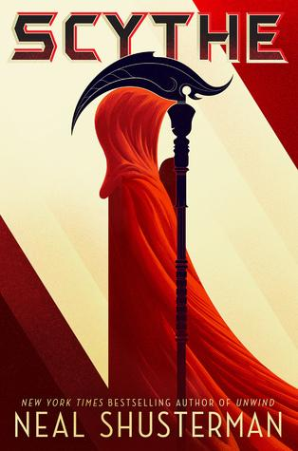
- Shusterman, Neal. Scythe. Simon & Schuster BFYR, 2017.
*From Boris Slager’s Booktalk
  - Summary: Scythe explores a post apocalyptic world in which a machine runs the world and humanity. In the novel no one dies as a result of old age, disease or accident but are chosen to die by the keepers of death called the scythes. Two teenagers are chosen to apprentice a scythe and face turmoil and trials along during their training, as they simultaneously compete for the single role as a scythe at the end of their apprenticeship.
  - Commentary: The novel is noteworthy because it exhibits exeter quality number two as it includes elements of “suspense...and tension brought about through narrative hooks and a fast pace.” The narrative hook of the tension and competition between the two teenagers highlights the prolonged suspense in discovering who will ultimately succeed and who will fail at becoming a scythe. The teenager’s competition with each other keeps the novel moving through a fast past of events and discoveries leading up to the final revelation.

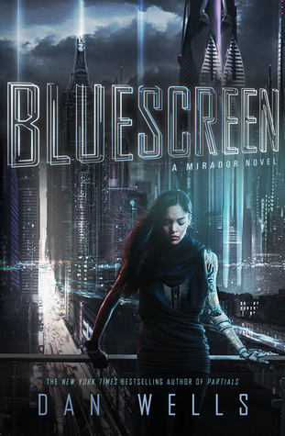
- Wells, Dan. Bluescreen. Balzer Bray, an Imprint of HarperCollins Publishers, 2016.
*Info from thedanwells.com
  - Summary: In 2050 the population on Earth has become obsessed with living life through a virtual world. In order to spend a majority of life in virtual reality an implant in the head is necessary. Many people are also taking a drug called Bluescreen that provides a sensory high. However, the main character Marisa soon finds out that the virtual world is not as perfect as she thought it was and Bluescreen is dangerous as there is a looming conspiracy beginning to sink in around her.
  - Commentary: This novel exhibits exeter quality number four because it shows characters who have experiences very different from those that readers will ever have and by doing so provides an outlet for readers to find growth and development in their own lives. As most teens will never be a part of living the majority of their lives in a virtual world, or uncovering a conspiracy theory in an attempt to save humanity, living the experience through Marisa provides a different encounter than they would have in their own life. Through reading the book, young adults can use the knowledge and experience of the characters to find growth and development in themselves and in their lives.

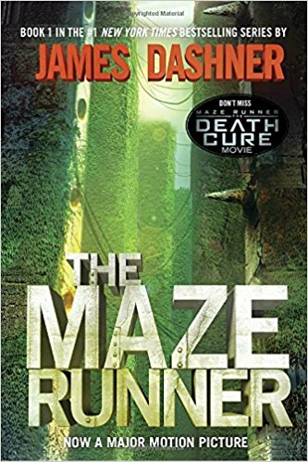
- Dashner, James. The Maze Runner. Delacorte Press, 2009.
  - Summary: A group of teenagers are part of a trial to find a cure for a disease called “the flare” that wiped out the human population. As if the teenagers were animals they are literally put in a cage-like maze with monsters and moving walls where they are sent to live and solve the puzzle to escape. The story centers around the expreinces of Thomas, a teenage boy who has been sent into the maze, and his part in helping his friends to escape while simultaneously uncovering the truth about his past.
  - Commentary: This novel exhibits characteristic number four from the Characteristics of the Best YA Literature because it includes a variety of genres and subjects. The Maze Runner, while being a post apocalyptic/post pandemic story, also includes the genres of adventure and romance. The characters’ experiences inside the maze are full of stops and turns that lead them on a grand adventure to find a way to escape their current situation. In addition, the novel threads a love story between the two main characters who become close due to their connection before they were placed in the maze and their ability to connect telepathically.

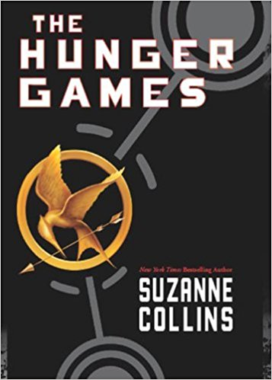
- Collins, Suzanne. The Hunger Games. Scholastic Press, 2008.
  - Summary: In post-apocalyptic America a new capital has formed surrounded by twelve districts who must provide one boy and one girl each year to fight to the death on broadcast television. Katniss volunteers to be a part of the competition to save her sister from competing and through her struggle for survival learns about love, friendship and hard choices. In the end only one person is supposed to win the Hunger Games, could it possibly be the girl that no one would expect?
  - Commentary: This novel exhibits characteristic number five from the Characteristics of the Best YA Literature because it includes stories about characters from different ethnic and cultural groups. The two main characters Katniss and Peeta come from the same district but have led very different lives due to socio economic status that are exposed through flashbacks during the story. In the novel the author describes the white people as being rich and the darker skinned people as being poor and this is elaborately displayed in the variety of characters that are developed throughout the novel.


- DuPrau, Jeanne. The City of Ember. Yearling, an Imprint of Random House, 2016.
  - Summary: In a post-apocalyptic world the human race has been saved by an underground city called the City of Ember. However, the lights that illuminate the city are beginning to fade and the infrastructure is beginning to crumble. Lina finds a message from the city’s builders that leads her and her friend on an adventure to try to save their city and people.

  - Commentary: This novel exhibits characteristic number six from the Characteristics of the Best YA Literature because it is optimistic, and the young adult main characters are making admirable accomplishments. The main characters exhibit an immense amount of courage in embarking to discover the meaning behind the clues to save their people. And in each step toward finding a solution the two accomplish more and more. Throughout the novel, all the way up to their final accomplishment, the main characters make many important and commendable achievements.

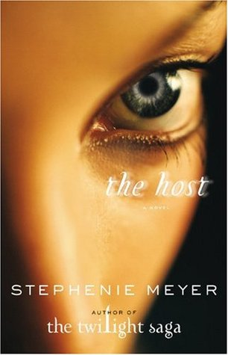
- Meyer, Stephenie. The Host: a Novel. Little, Brown and Co., 2008.
  - Summary: In a post-apocalyptic world aliens who are called “souls” have inhabited the earth and implanted themselves into the bodies of humans. Once implanted the human’s soul is erased leaving behind just their past memories. Except in the case of Melanie. Her host Wanderer finds Melanie to be present inside the brain and the two develop an unlikely friendship in the effort to save Melanie’s loved ones.

  - Commentary: This novel exhibits exeter quality number one because it revolves around a plot full of time shifts and differing perspectives. The story continually switches between the perspective of Wanderer and Melanie and shows the internal struggle/dialogue between the two. The novel also includes time shifts as Wanderer gains access to Melanie’s memories of the past that she tries to desperately hide from her counterpart.

This and all other quotations are taken from Literature for Today’s Young Adults by by Aileen Pace Nilsen and Kenneth L. Donelson.

