Johnson Huynh
Professor Warner
English 112B
March 9th 2019
Life in a Fishbowl
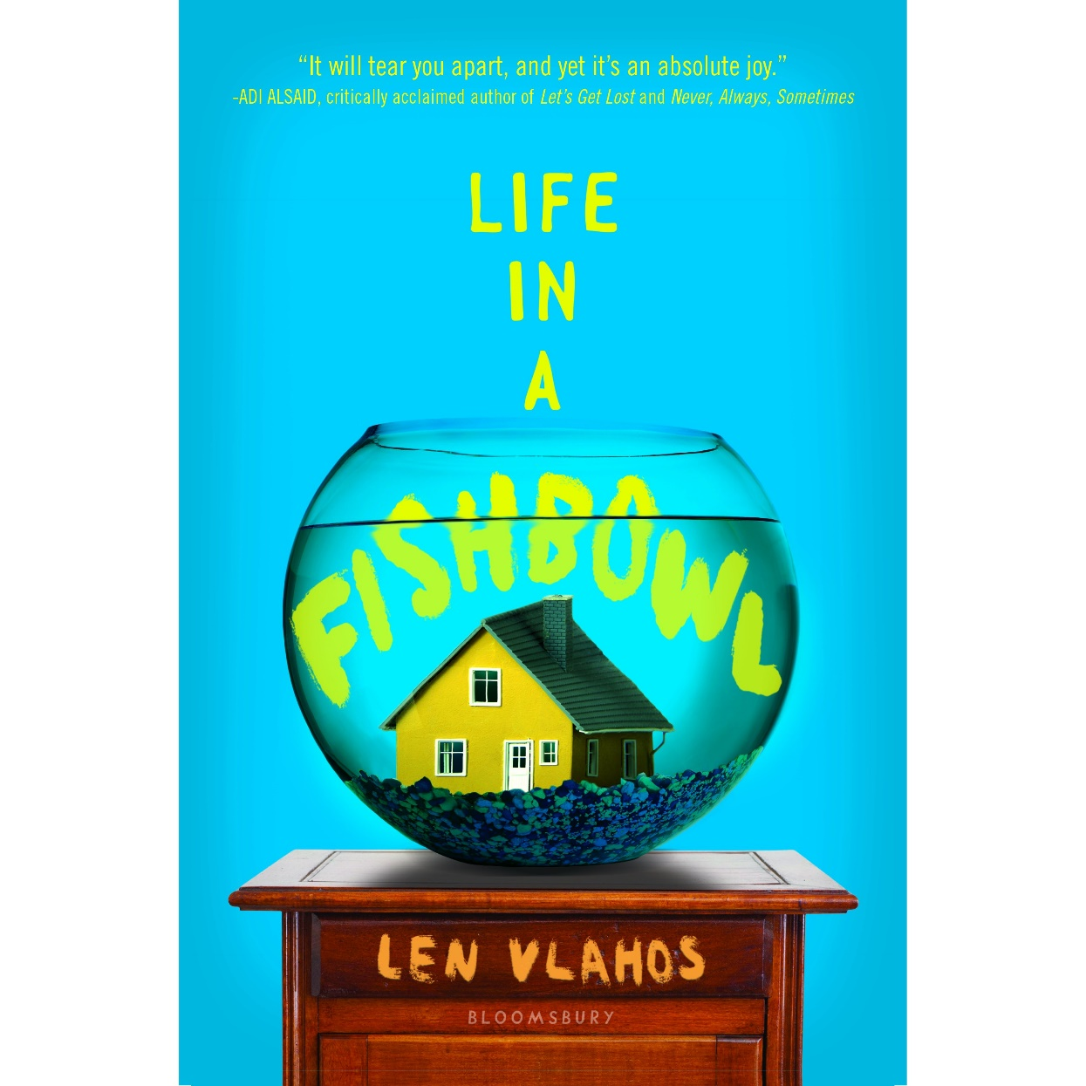
About the Author:

- Len Vlahos has also written other books which are Scar Girl, and The Scar Boys
- Len Vlahos dropped out of NYU film school to play guitar and write songs
- His band broke up in 1987 where he then began to dive into his love for books.
- In 2015 Len Vlahos purchased the “Tattered Cover” bookstore in Denver, Colorado.

About the Book
Life in a Fishbowl focuses on the story of the Stone family. The Stone family is made up of the father Jared Stone, the wife Deirdre Stone, and the two daughters Jackie Stone and Megan Stone. As the book begins it is revealed to both Jared and the reader that a new member will be joining the family; a tumor in Jared’s brain. A doctor informs Jared that there is a “high-grade glioblastoma multiforme” in his brain, which as Jared discovers throughout the book, causes Jared to become more and more forgetful. Jared, stupefied after being told he likely has only four to five months left to live, quickly switches his focus on making sure his family will survive without him. Jared needs to feel assured that they will not have any financial issues after he passes, as he knows that his daughters are going to college soon enough. In a last minute bid to secure the financial future of his family, he decides to sell the remainder of his life on eBay to the highest bidder.

Quotes
“’Oh sweetie,’ she said, tearing up. ‘I was making a joke.’
Jared paused for a second and then smiled. ‘Oh, I see. That is pretty funny.’ He put his head back down.
They lay there for a while, like two kids in a summer field looking up at the stars.
‘Why didn’t you tell me?’ she asked, keeping her eyes focused on the ceiling.
‘I don’t suppose you’d believe me if I said I forgot.’
‘Is that true?’
‘No,’ he said quietly. ‘I suppose it’s not. I guess I wanted to figure out how to make everything okay first.’
‘And selling yourself to some psychopath on eBay was your answer?’
‘Like I said, I’m confused. I’m not even really sure what I’m saying to you right now. Am I making sense?’
Deirdre rolled over to look at her husband to see if he was serious; she didn’t see a hint of irony or mischief on his face.
‘Don’t you think the girls and I can take of ourselves?’
‘I guess didn’t think,’ he said. ‘They were both quiet for a while before Jared added, ‘Although, you know, I did get a bid for a million dollars. I think it’s from a hooker or something. The name is SisterBJ143.’
Deirdre rolled onto her side, facing away from Jared.
‘What?’ he asked, taking her hand. ‘I won’t do anything you wouldn’t want me to do.’
‘Then don’t die.’ She said it so softly she wasn’t sure Jared had heard her. When Deirdre rolled back over, she saw serpentine streaks of tears carving rivers on her husband’s cheek “(Vlahos 55).
Significance: This is soon after Deirdre, Jared’s wife, discovers that Jared has a terminal illness and also that he wants to sell the remainder of his life. This text does a great job of showing how Vlahos can still keep up the humor even during a very serious portion of the story, and then still tie it back to a somber image of Jared still overcoming the idea that he will soon no longer be able to fulfill his family’s wishes.

“But just because Jared was sick didn’t mean the world had to turn completely upside down. Deirdre had had enough.
‘Are you fucking kidding me? All of America watching our daughters watch their father die? This is supposed to be good news?’
‘But, D,’ he began.
‘But nothing. We can’t go through with it.’
‘I already signed. We’re committed.’
‘No, Jared you’re committed. We’re outta here.’ Deirdre got up from the table and started to leave the room. She made it all the way to the door before Jared said, ‘It’s five million dollars.’
Deirdre stopped in her tracks.
‘D, I’m going to die. No matter what we do, I’m going to die. Let’s at least cash in.’
Deirdre didn’t turn around, but she didn’t leave the room, either.” (Vlahos 98)
Significance: This passage is the one that made me feel like the parents were realistic. In a perfect world, both parents would realize that no matter how much the cost, the strain of putting your teenage daughters under the constant eye of the national television would very likely be unhealthy. But since both parents are caught off-guard, having to deal with the inevitable truth of Jared’s shortened life, the idea of five million dollars creates a very important lapse of judgement. We all like to think that we wouldn’t sell out no matter how large the cost, but, could you truly pass up five million dollars? How much would you truly value your privacy?
“When Jared woke from his nap, he found that he had soiled himself. It was the first time it had happened, and it was, he knew, a sign of how far his disease had progressed. He stood up to go to the bathroom and clean himself off and immediately fell back to the ground with a thud.
‘What the fuck,’ he was able to mutter.
He gathered his wits as best he could and pushed himself up on his hands and knees; he crawled to the bathroom, where he more or less collapsed. Jared knew he should probably call for Deirdre, but he was too embarrassed.
‘Cancer,’ he said aloud, ‘is a bitch.’
…
Jared’s secret stayed intact for exactly five hours, until Life and Death aired that night. The cameras had caught everything, including the ‘Cancer is a bitch’ line, right up until he closed the bathroom door. It all ran before the opening credits.” (Vlahos 201)
Significance: This passage is one of the most memorable passages for me. The book goes in great detail on how much Jared has been struggling just living a normal life, when only weeks ago he was in tip-top shape ready to take on the world. Now, he has soiled himself and can’t even walk to the bathroom on his own. How can a person see themselves in the mirror after such a sharp decline? At least he can hide his weakness he likely thinks to himself, until he sits down and realizes that once again, the world gets to watch him struggle. This part really shows how disgusting reality TV can be, as the harsh and genuine struggles of another person become entertainment for others. Simple popcorn to eat for the next 60 minutes of their lives.

Complexity
Lexile Level: 900L
Grade Level: 6-7
I would recommend this book for 6th graders and on as the book goes very deep into the death of a loved one and coming to terms with it while under high amounts of stress. There is very strong imagery of Jared essentially withering in front of Jackie which might be too disheartening to young readers, so I’d recommend it to mainly 6th graders and on.
Dale-Chall: 6.7
Grade Level: 7th/8th
There are a fair amount of “big” words used in this book, often times when the personification of the tumor comes into the spotlight. This means that it’s likely that middle schoolers and up who have gained some basic knowledge of biology that are able to appreciate this book more than others.
ATOS: 6.1
Grade Level: 6
Once again the main reason the score would be geared towards middle schooler is likely because of both the personification of the tumor and the touchy subject matter of dealing with the slow loss of a loved one.

Methods for Teaching
- Seeing as to how the novel focuses a lot about media can spin or frame people in a certain way, have the students write about whether they truly believe reality TV show stars are the way they are portrayed on TV.
- There is also a good portion of the book where Jackie and a new friend Hazel work together through an online video game called World of Warcraft. Ask the students if they have made any close online friends and to write about how they met or why they’re comfortable with their online friends. If the students have not made and online friends, ask if they would be comfortable with having online friends.
- A large portion of the book is on witnessing the slow decline of their father figure Jared. It is revealed early that Jared was already in works to support assisted suicide in his state of Oregon. Ask the students to write about whether or not they see assisted suicide as an okay thing to do and give reasons as to why. The teacher can also ask this before and after the book is done being read, to see if anyone had changed their mind.

Rationale
- This novel struck a personal cord with me once the internet community came into play. In the age of information, it is not uncommon for young people to turn towards their online communities in search for support in their stressful physical lives. This book does a great job of showing that supportive side of the internet in a healthy, non-addictive way which can directly connect to other students who participate in online communities.
- With the age of information also comes some downsides. Now that information can be shared with a single click, misinformation runs rampant across the internet, and now with sure methods to trick the viewers/readers into believing certain storylines. This book helps the readers understand how they should not believe everything they see on TV or the internet, as there is a lot of information missing from the snippets that they do see.
- The death of a loved one is always a difficult part in life that nearly everyone must go through. To some, it may be even harder to see their loved one slowly die right before their eyes, day after day. This book does a great job dealing with those emotions and going into the inspiring mind of Jackie, the daughter of Jared, and how she resolves herself to come to terms with her father’s death and escape the confines of the reality TV show.

Sources:
http://review.cuckoowriters.com/wp-content/uploads/2016/12/life-in-a-fishbowl.jpg|
https://www.publishersweekly.com/images/data/ARTICLE_PHOTO/photo/000/019/19255-2.JPG
https://www.teenreads.com/authors/len-vlahos

https://upload.wikimedia.org/wikipedia/commons/thumb/4/48/EBay_logo.png/800px-EBay_logo.png

