Jessica Smith
ENGL 112B
Dr. Warner
September 27, 2024
Fallout
By Ellen Hopkins
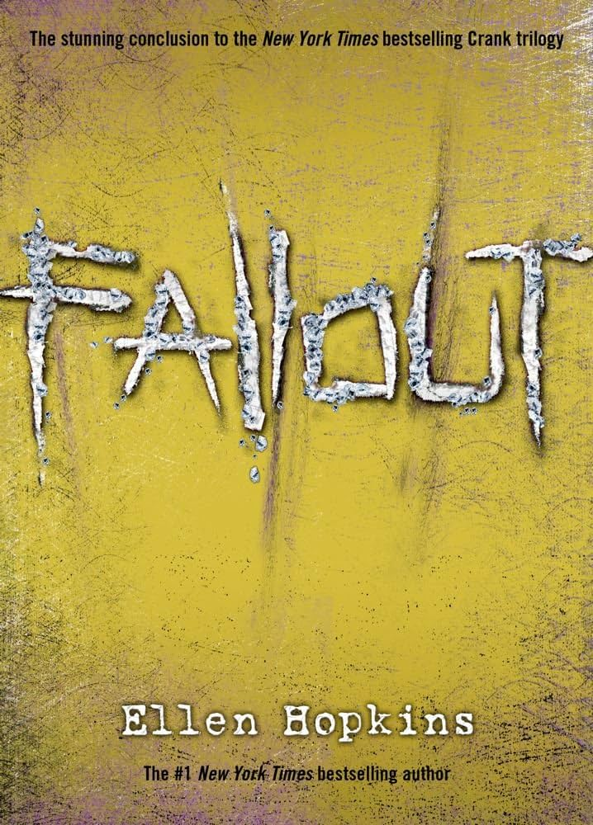
Photo source: https://www.amazon.com/Fallout-Ellen-Hopkins/dp/1416950109

About the Author
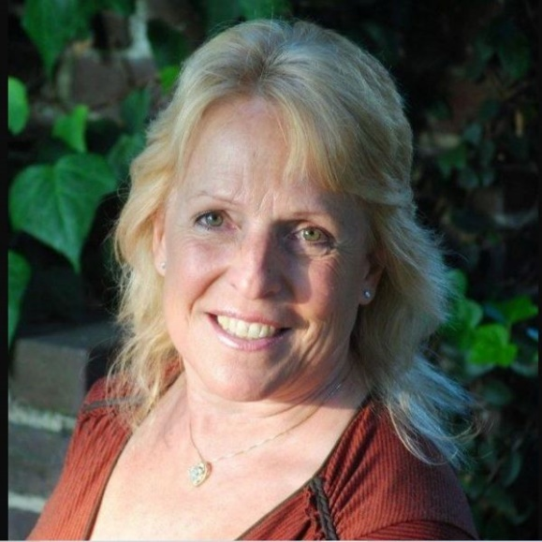
Photo source: https://www.simonandschuster.com/authors/Ellen-Hopkins/20799681
Ellen Hopkins, born March 26, 1955, in Long Beach, CA, is notorious for her YA books that tackle tough subjects such as drugs, alcohol, sex, and the abuse of all three. Hopkins grew up in Palm Springs, then headed to Santa Ynez Valley where she graduated high school. She ended up studying journalism in college at both Crafton Hills College and UCSB. Hopkins started to write at just 9 years old, and during her formative years won every creative writing contest she submitted to. She has been appointed with the title of “Most Banned Author in America” with all 14 YA novels being removed from schools. Apart from being an author, Hopkins was a talented equestrian.
Author website: https://ellenhopkinsbooks.com/

Book Summary
Fallout by Ellen Hopkins is a riveting finale to the infamous Crank trilogy. This book follows the lives of three people – Hunter, Autumn, and Summer who all share the same mother, Kristina Snow. For context, Kristina is the main character in the first two books as it follows her terrifying journey as a drug addict. Estranged, each of the kids is found to be in their own horrible predicament and is trying not to spiral out of control. Eventually, the kids and Kristina are reunited, but it is not a happy family reunion. Hunter, Autumn, and Summer learn about their mother’s dark past and must navigate through trials and tribulations to keep it all together. From this, Hunter, Autumn, and Summer find ways to cope with the hardship and gain a real shot of being a family… finally.

Key Quotes
Quote #1
“They don’t call it the monster for nothing. It chews people up, spits ‘em out, often unsalvageable. / So why have I been tempted to take a spin with the monster?” (61).
- This quote comes from one of Summer’s passages as she talks about her mother Kristina’s addiction to meth and how it is not only ruining her own life, but Summer’s as well. This is essential to note that the theme of addiction affects everyone who involves themself with the addict. Summer takes from her own experiences to explain to the reader just how bad this drug is. This passage comes directly after Summer recollects the last conversation she had with her mother where she truly realizes just how unattached and oblivious Kristina really is. Summer’s dialogue also shows her knowledge of addiction and how it is luckily being painted negatively on her.
- The second half of this quote is significant because it touches on the genetic predisposition of addiction. Summer is tempted to try meth because it is all she knows about “feeling good” but recognizes that it would bring her down the same path as her mother. Plus being a teenager and being told that something is bad instantly raises the curiosity level tremendously. This does not help the possible susceptibility.
Quote #2
“I have never even once in my life felt like this before. Like anything is possible. No matter how messed up I am, this amazing guy cares about me. Maybe even loves me. That’s seriously crazy.” (261).
- This quote is taken from a passage from Autumn. She talks about her blossoming relationship with a guy named Bryce and how she feels a positive change within her. Autumn comments on how she feels broken, or even less than, another person her age because of the hardship she endures daily. This is significant because there is a parallel to Kristina regarding this dialogue. Autumn is shocked to find that someone can love her despite her flaws considering her mother has not one person in her corner. This is an optimistic outlook that is rarely found in this book.
- Autumn’s love and obsession with Bryce can be seen as her own personal drug. Instead of falling down the same path as her mother, Autumn looks to intimacy and connection to feel fulfilled. However, addiction doesn’t solely relate to drugs…
Quote #3
“God, how I want to let her in. / But I know she’d only shut me out. / … the fact is, she’s incapable of loving me like a mother should. / So I can’t let myself love her like a daughter should. / To unlock myself in such a way would simply be an invitation to heartbreak.” (291).
- This is a powerful quote found in one of Summer’s passages. Again, she previously converses with her mother but this time she lets her have it. This dialogue is Summer reflecting on the conversation and coming to terms with how she feels about it all. She desperately wants her mother, not just a mother figure. The pain that will come with letting Kristina back into her life will be far greater than the love and care she will receive. Deep down Summer knows that addiction still clings onto her mother and any sort of connection will eventually cease to exist when Kristina starts using, so why bother?
- This sentiment is important for Summer’s self-growth because it shows that she prioritizes her wellbeing. Protecting herself also saves her from potential harm done by Kristina or others who also participate in using drugs.
- Even though this is said by Summer, this quote relates to both Hunter and Autumn as well. All three children want nothing more than to have their mother at full capacity, but they all understand just how impossible that is. Knowing that Kristina is genuinely unable to be who they need her to be helps in the decision of keeping her at arm’s length, or even farther.

Classroom Use
This section is a bit tricky. Personally, I have never read a book like Fallout in class that was assigned by a teacher. The books that were handpicked by the teacher often dealt with sensitive and/or risqué topics, but never to the extent that Hopkins writes in her books. I would like to use this book as a chance to educate and discuss difficult subjects. Some teens may be unaware that the issues that Hunter, Autumn, and Summer face are hard realities. To other teens, the subject matter might be all too familiar. It is important for teens to understand that whatever hardships they may face, they are not alone.
Fallout can also be used to introduce free verse writing. Hopkins’ writing style is unique, fast-paced, and addicting. This is an excellent opportunity to ease into a poetry lesson and show teens that reading and writing doesn’t have to feel daunting. I would want this idea to spark creativity and inspiration to all who are interested in this medium. As a homework assignment, or class project, I would have my students create their own free verse passage that is personal while (gently) pushing them to have inner dialogue with themselves to aide in feeling emotions genuinely and fully.

Why should teenagers read Fallout?
Due to the crude subject matter, one might not believe that such a book should be read by teens. However, I beg to differ. While Fallout absolutely portrays the dangers of abusing drugs, alcohol, and sex, this book also serves as a reminder that there are always consequences to one’s negative actions. As a teen, I remember all too well that feeling of invincibility and how I was in total control. Fallout can help serve as a reminder that if you choose a harmful path, it will come back to you at some point. This lesson can further educate teens on how to treat themselves and others. This isn’t supposed to be based on fear but rather a reminder for when those canon teenage events arise. Hopkins’s book is a teen-friendly tool on how to handle situations that teens would usually never want to talk to their parents about.

How it fits best in Chapters 4-8 in Adolescents in the Search for Meaning
Chapter 4: “Books about Real-Life Experiences”
- The entire book is based on depressing real-life experiences such as addiction, sexual assault, loss/grief, infidelity, and peer pressure. All three teens in Fallout experience these firsthand.
- Many teens may have unfortunately been able to relate to some or all these experiences. Relatability could be helpful in the healing process.
- Fallout could also be helpful to teens who have friends and/or family that are struggling with those experiences. This can teach them how to listen and have sympathy and empathy.
Chapter 5: “Books about Facing Death and Loss”
- Hunter, Autumn, and Summer all face the loss of having their mother, Kristina. She did not die, however, her addiction to meth poured into the lives of her children.
- All three teens lost out on a stable family unit as they are all living separately, and in places they feel they do not belong.
- I could also argue that the teens face the death of who they thought they were after finding out about their mother’s past.
Chapter 6: “Books about Identity, Discrimination, and Struggles with Decisions”
- All three teens struggle with their identity as they piece together just who exactly they are because of where, and who, they come from.
- Hunter struggles with the decision to confront his biological father without really knowing if it is him.
- Autumn struggles with the decision to be intimate with Bryce as well as meeting her biological mother (Kristina) and father.
- Summer struggles with the decision to be with Kyle instead of Matt, and to run away with Kyle after being put back into foster care after her father gets a DUI and loses guardianship.
Chapter 7: “Books about Courage and Survival”
- Hunter has the courage to stand up to his biological father and confront him for being a product of rape. He also finds the courage to tell his mother how he feels about her. He survives with the help of his girlfriend, Nikki… and some weed and Jack Daniel’s.
- Autumn has the courage to meet her mother Kristina and let someone in intimately (Bryce). She survives because of her Aunt Cora who has been her pseudo mom since she was little.
- Summer has the courage to report one of the foster kids for sexually assaulting another. She is also courageous in getting her father to admit he needs to do better for her. Summer survives at first with Kyle, but ultimately survives her future after connecting with Autumn.
Chapter 8: “Books on Allegory, Fantasy, Myth, and Parable”
- Fallout can be seen as an allegory for what happens when consumed by addiction. Not just to oneself, but to those around them. It seldom affects just one person.
- Hopkins’s book can also be a parable for infidelity, drug abuse, and assault. Fallout gives a moral lesson on consequences that stem from these.
  - Hunter’s guilt and confession to Nikki for cheating, and Kristina’s guilt and embarrassment over her meth addiction and how it affected each of her children.
Quantitative
Word Count: 75,679
Page Count: 662
Lexile Level: NP, age range 14-17
Interest Level: Upper Grades 9-12
AR: ATOS Book Level 3.6; AR Points: 10
Dale-Chall: 4th grade level, age 9 and older
Flesch-Kincaid: 2nd grade level, age range 7-8

Qualitative
Structure
- This book has three points of views – Hunter, Autumn, and Summer. Each POV is represented by one of Kristina’s children.
  - All are first-person.
- Although separated, each teen’s story takes place at the same time as the others. The timeline matches throughout the book and sometimes overlaps.
  - Parallel plot.
Language Conventions and Clarity
- Each passage is written in free verse form.
- The vocabulary chosen is simple and easy to understand.
- All punctuation and grammar are used appropriately.
Knowledge Demands
- There is major context given in the first two books in this trilogy, Crank and Glass, that follows Kristina’s story.
  - The books before Fallout include Kristina’s introduction to meth, her children’s biological fathers, and her overall downfall.
- Even though this book is targeted toward teenagers, they will need to comprehend the dangers of crystal meth and the horrors of sexual assault.
Levels of Meaning
- Students will discover how traumatic the consequences of poor decisions can be. This is a major life lesson.
  - Starting with Kristina and how her addiction single-handedly ruined the lives of everyone that knew her, and ending with how each teen suffers a consequence from a wrong choice.
    - One prime example being Hunter cheating on Nikki.
- Teens reading this book will hopefully understand that they can create sanctuaries even in places that don’t promote it.
  - Hunter’s job at the radio station as well as Nikki, Autumn with her Aunt Cora, and Summer with Kyle.
- Learning about the unsettling reality of drug and alcohol addiction
  - Each teen witnesses someone in their close circle abuse meth, pills, and alcohol. Seeing this firsthand helps them realize that is not the life they want for themselves.

