Book Talk: Purple Heart


https://tantor.com/author/patricia-mccormick.html
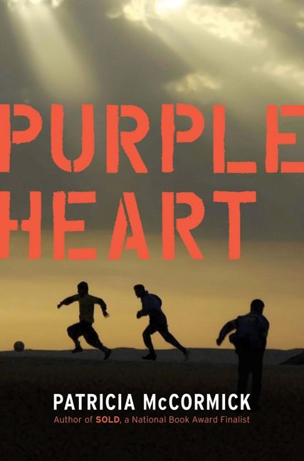
https://www.harpercollins.com/9780061730900/purple-heart/

Patricia McCormick is a former journalist who has authored two National Book Award finalists. She has won much acclaim for her books being centered on hard-hitting subjects, such as this book. To research Purple Heart, she traveled around the country to interview soldiers as well as the families of soldiers who went to Iraq and did not return. She also took part in a peace demonstration with veterans of the Iraqi war. You can visit her web page at http://www.pattymccormick.com/

Book Summary
Purple Heart starts out with Army Private Matt Duffy waking up in a hospital in Baghdad during the war in Iraq. He awakens to a Lieutenant Colonel awarding him with a Purple Heart medal for “wounds sustained in battle.” He has no memory of why he is injured but is confused as to why one image in particular haunts him: an Iraqi boy being shot in the chest. As Matt recovers and eventually gets released back to his unit, he begins to remember bits and pieces of the scenario that resulted in his head injury and trip to the hospital. As he wrestles with the uncertain guilt of possibly being the one who killed the little boy, he worries that the traumatic event has changed him and in a way that affects him negatively in combat, which can be the difference between life or death for him and his squad mates.

Pertinent Quotes
“Matt had no candy left, but the kid was so skinny… That’s what happens when you try to make friends with these people.” (29,30)
-
Throughout the book, Matt struggles with the indecision of what kind of people the Iraqi’s are. He sees them living their lives as best they can in a war riddled part of the world while others are self-sacrificed bombers intent on killing Matt and his troop mates.

“So tell me, did everyone know?... But when it mattered most, Justin still had his back and he had Justin’s.” (191,192)
-
This is CRUCIAL to the book because it shows that no matter how rough, how ugly or how traumatizing it gets out there, you have your brothers and sisters fighting next to you and for you, they are your family.
“He looked up and saw the black-and-white ball… and watched as it sailed into the crayon-blue sky.” (198,199)
-
The story closes with Matt noticing the apparent “ugly” habits and intricacies of the Iraqi people as described by his friends in his unit. But the last thing he notices is what his hopeful viewpoint is of these people; that they are also living their own lives as best as they can in an unfortunate part of the world.

Text Complexity
Lexile: 760L
Ages: 11-14

Atos: 5.1
Ages: Grades 9-12

In the Classroom
I would use this book in 11th and 12th grade Literature classes in order to give them an in-depth look at struggles that most of them would never experience. The reading is fitting for this age group as beginning readers.
One question asked about the story and main character would be what they notice about the main character’s point of view of the Iraqi’s around him, as compared to the other soldiers in the book.
Another would be: Does the main character’s point of view change about the people, despite the horrible acts some of them have committed against the American troops? Would YOUR point of view change if you were in Matt’s shoes?
Can you relate the Soldiers’ outlook of people around them to how us as civilians view each other here in the U.S.?

Why Should Teens Read This Book
McCormick executes a few qualities from the University of Exeter’s study.
One being the well-structured plots going beyond simple chronologies to include time shifts and different perspectives. Throughout the book, Matt is constantly going through uncontrollable flashbacks to the gun-fight that sent him to the hospital. This is how he recollects what actually happened towards the end of the book.
Another being characters who go beyond typical experiences so that readers can use the fictional experiences to learn and develop in their own lives. Like explained earlier, most 11th and 12th graders won’t enter into the military and won’t ever experience the struggles Matt-the main character-endures. Yet the mental and moral adversity he endures may be relevant to this age group.
Lastly, McCormick made sure to do research and interviews in order to portray themes that inform truthfully about the wider world so as to allow readers to engage with difficult and challenging issues relating to immediate interests and global concerns. It’s a book on the war in Iraq!
BUT!
According to the National Center for Education Statistics, for the 620,650 18-19-year-old boys and girls who joined the armed forces from 2003 to 2008-6 crucial years America was at war with Iraq-or the thousands of teens that continue to enter the military, this book serves as a relevant portrayal of the ideologies and comradery in the life of a veteran.

Eric Perez
Fall Semester 2018

