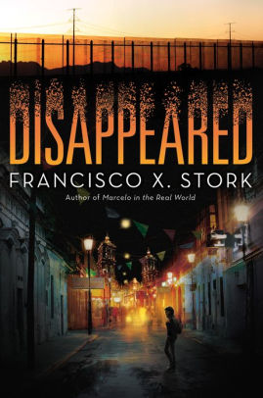
About The Author
Francisco X. Stork was born in 1953 in Monterrey, Mexico. He is the author of seven novels, including Marcelo in the Real World, winner of the Schneider Family Book Award for Teens and the Once Upon a World Award, and The Last Summer of the Death Warriors, which was named to the YALSA Best Fiction for Teens list. https://www.franciscostork.com/

Book Summary
Sara Zapata's best friend has disappeared, kidnapped by the web of criminals who terrorize Juarez. Sara receives a death threat - and with it, a clue to the place where her friend is locked away. Emiliano Zapata has fallen in love with Perla Rubi, who will never be his so long as he's poor. Both Sara and Emiliano are faced with tough decisions as they try to navigate their ways through the many twists and turns thrown at them.

Quotes
“Maybe in other cities in the world, a young woman can be one hour late and it isn’t cause for worry. In Juarez, that is simply not possible.”

This is a quote from the article Sara wrote about Linda’s disappearance, it does a great job of expressing the overall hopelessness that plagues the city of Juarez. At the same time it shows Sara’s strong resolve, a theme that persists throughout the entire book.

“I wanted to talk to you tonight but you didn’t want to come to the phone. I don’t write very good. But I am still your father, even if you don’t think so.”

This quote is a letter from Sara and Emiliano’s father. His leaving is the source of all of Emiliano’s struggles and this being the only letter he opened from his father is an important point. This quote not only encapsulates Emiliano’s pain, but a consistent issue that he has to deal with as the book progresses: whether to be satisfied with being a good person or take the money and security that comes with being a bad one.

“Emiliano stares at him. This dying man’s last wish is for his son to know that he was loved by his father.”

This is a huge moment for Emiliano and it connects back to the letter from the beginning. This is a major turning point for Emiliano as he struggles with the decision in front of him. I also chose this quote because after this point in the book it is difficult to find a quote that doesn’t give away a lot of the twists.

Text Complexity
Grade Level: 6-12
Lexile Measure: 710L

Use in the Classroom
This book is perfect as an intro to a unit of study. The language used is easy enough to keep students interested while the twists and turns of the book could lead to some very interesting group talks. The recommended grade level is 6-12 and I would agree. There is some bad language and controversial topics but it isn’t overly inappropriate for the younger end of that age range. I would say it fits best with chapter 4 from Adolescents in the Search for Meaning: Tapping the Powerful Resource of Story, but it could easily fit into chapter 6 or 7 as well.

Recommendations
I would definitely recommend this book. Although Sara’s part of the story is a little less relatable, it captures your attention immediately. Emiliano’s story is much more relatable to anyone experiencing family separation issues and does a great job of addressing a problem that many across the world have experienced themselves.

